**How Much Do Fans Love Justin Timberlake?**

JT’s concert promoter wants to find out how much fans enjoy the concerts. He will ask fans, “From 1 to 100, where 100 is the most, how much did you enjoy the concert?” The section he wants to survey has 50 seats (5 rows x 10 columns). The stage runs along the northern edge of the venue (where Justin is pictured). He wants to take a sample of 10 seats.

1. **Method #1**:

Take a simple random sample (SRS) of 10

fans. Explain below the steps you used to

obtain an SRS.

**Label seats from 01 to 50 (starting from the upper-left corner and ending at the lower-right corner).**

* **Use the random number table to select 1numbers, ignoring repeats and numbers**

**with value of 51, 52, …, 98, 99, 00.**

* **Select person in corresponding seat.**

1. **Method #2:**

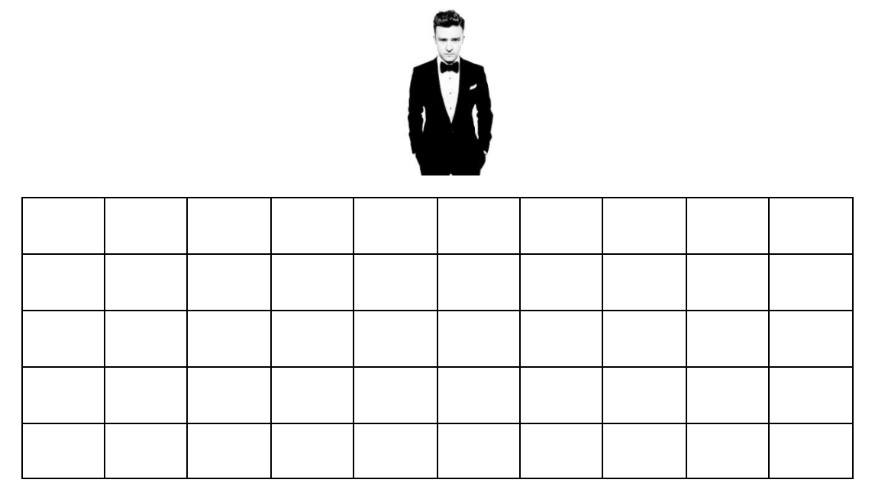Randomly choose 2 fans from each

horizontal row.

1. **Method #3:**

Randomly choose 1 fan from each

vertical column.

1. Which method do you think is best? Why?

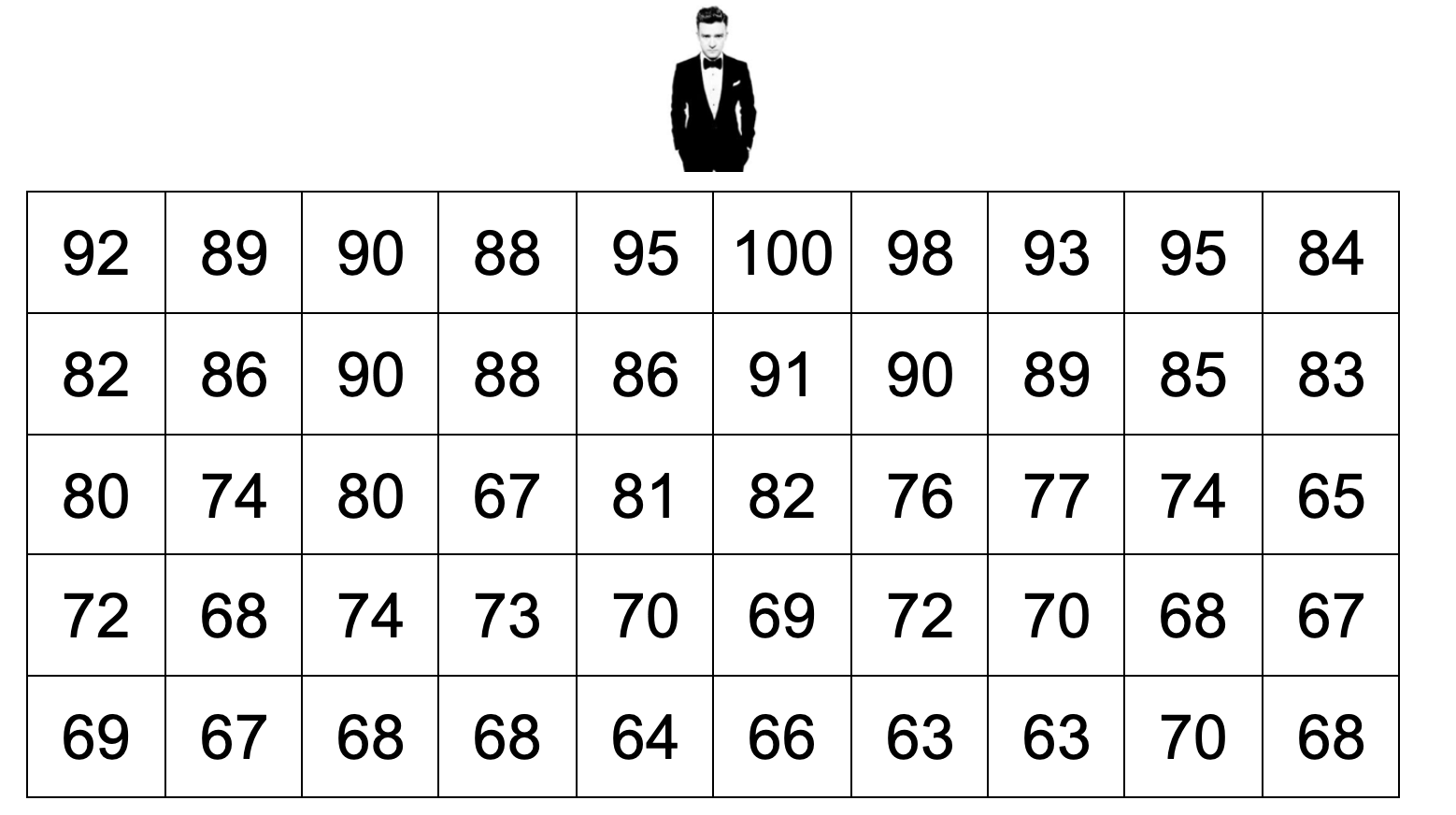

1. Now, it’s time for the actual data. For each of your samples on the previous page, calculate the average enjoyment.

Sample #1: Average =

Sample #2: Average =

Sample #3: Average =

**Method #1: SRS**

 average enjoyment

**Method #2: Stratify by Row**

 average enjoyment

**Method #3: Stratify by Column**



average enjoyment

Check Your Understanding:

Important Ideas: **Steps: Label, Randomize, Select**

* SRS ( )

Choosing a group from a population so that every individual and group of individuals is likely to be chosen.

* Stratified random sampling:

Splits population into groups ( ) and chooses an from each strata.

* Cluster sampling:

Splits population into groups and randomly select groups.

To score the AP Statistics Exams ETS hires Exam Readers, Table Leaders, and Other Leadership. Each reading room consists of 16 Exam Readers and 2 Table Leaders. There are 100 reading rooms. The 18 members of Other Leadership work together in a room.

1. Describe how to select a stratified random sample of 36 people hired by ETS to score the AP Statistics Exams. Explain your choice of strata.

**Use the employer’s role as strata.**

* **Label all of the exam readers from 1 to N.**
* **Use the table of random digits to select 12 unique numbers from 1 to N.**
* **Select the corresponding individuals.**
* **Repeat the process to select table leaders of 12 members of other leadership.**

1. Describe how to select a cluster sample of 36 people hired by ETS to score the AP Statistics Exams. Explain your choice of clusters.

1. Explain a benefit of using a stratified random sample and a benefit of using a cluster random sample in this context.

**Identify what is wrong in each of these surveys. Be sure to explain.**

1. The mayor of Springfield is interested in finding out the average age of people in the city. He obtains a list of all of the landline telephones in the city, and then contacts a simple random sample of 300 people. He uses the data from the sample to estimate the average age of all the people in the city.

1. What is wrong with this survey?
2. Do you think the Mayor will over or underestimate the true mean age of people in Springfield? Why?

2. The administration at a school wants to know the proportion of students that did all of their homework last night. They select a simple random sample of 100 students and send an email to each of them asking if they did all of their homework last night. Of the 40 responses, 36 of the students said that they did all of their homework last night (90%).

a. What is wrong with this survey?

1. Do you think the administration will over or underestimate the true proportion of students who did all of their homework last night? Why?

3. Boy Scout Peter M. wants to know the proportion of people in his neighborhood who support the Boy Scouts. He takes a random sample of 30 homes and visits them dressed in his uniform.

a. What is wrong with this survey?

b. Do you think Peter will over or underestimate the true proportion of his neighbors who support the Boy Scouts? Why?

